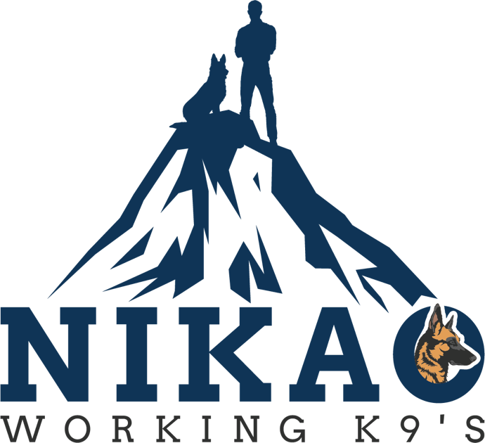

Nikao Working K9’s LLC Purchase Agreement/Contract

Thank you for choosing a Nikao Working K9’s LLC puppy. We want to ensure you that we will continue to be available after your new puppy goes home with you. If you have any questions about your new Belgian Malinios puppy we will do everything we can to answer you accurately and in a timely manner.

Date of Birth: ________________________
Male/Female: ________________________
Dam: _______________________________
Sire: ________________________________

Purchase Agreement
1. Please read the agreement/contract completely before signing.

2. We require a $500 dollar deposit in order to hold the puppy of your choice.

3. This deposit is non-refundable. However, if a health problem arises with your puppy the deposit can be transferred to another puppy or a full refund will be given.

4. The puppy (invoice) must be paid in full before leaving Nikao Working K9’s location. We accept all major Credit Cards, Apple Pay, Google Pay, etc. or cash. (No personal or business checks)

5. Your puppy will be ready for their new home when it is 8 weeks old or older.

6. Nikao Working K9’s LLC assumes no responsibility for said puppy’s actions, training difficulties or behavior problems.

7. The buyer agrees the puppy shall not be sold, transferred, or given to any retail or wholesale establishment for the purpose of sale or resale to the public or to any research institution where medical experimentation or other practices take place.
8. Nikao Working K9’s LLC reserves the right to give only limited registration on any puppy. (Meaning no breeding rights) If at sometime in the future you would like to breed your K9 feel free to contact us to discuss the pairing.
9. When registering your puppy no offensive names shall be used.
10. We will always take back a puppy from our breeding program. There will be no refund of any kind and the puppy is to be returned with its original paperwork.
11. Nikao Working K9’s LLC reserves the right to refuse sale to anyone for any reason.

12. Nikao Working K9’s LLC assumes no responsibility for any expenses from negligence from the buyer incurred after the sale.

I/we the Buyer(s), certify that I/we have read the purchase contract/agreement, understand its contents and I/we herby agree.
Seller: Nikao Working K9’s, LLC.

Buyer(s): __________________________________
Date: ___________________

Address: __________________________________

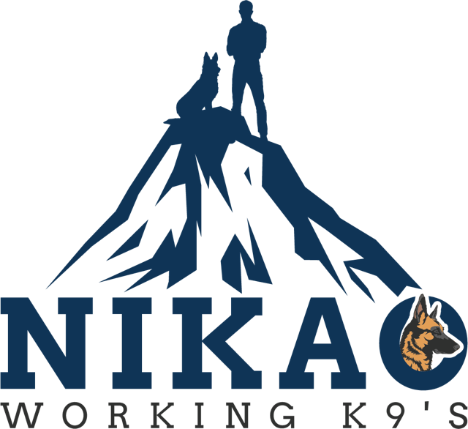

Nikao Working K9’s LLC Health Guarantee
1. The puppy is guaranteed to be in good health at the time of pick up or delivery.
2. The puppy will be up to date on shots and worming at the time of pick up or delivery of the puppy. It is your responsibility to continue the vaccinations and worming till the vaccination schedule is completed. We recommend keeping your puppy away from other unvaccinated dogs and dog parks until he/she has completed the entire vaccination schedule.
3. This health guarantee covers any genetic illness, hips and elbows and eyes for 24 months.

4. This guarantee does not cover any health issues caused by neglect or injury from the buyer.
5. This guarantee does not include minor illnesses and health issues such as colds, allergies or umbilical hernias.

6. Nikao Working K9’s LLC assumes no responsibility for any medical expenses from negligence or injury from the buyer incurred after the sale.

I/we the Buyer(s), certify that I/we have read the health guarantee contract/agreement, understand its contents and I/we herby agree.
Seller: Nikao Working K9’s, LLC.

Buyer(s): __________________________________
Date: ___________________

